

**Conjugate Heat Transfer Analysis of a body using Computational Fluid Dynamics**

*A Graduate Project Report submitted to Manipal Academy of Higher Education in partial fulfilment of the requirement for the award of the degree of*

**BACHELOR OF TECHNOLOGY**

**In**

**Aeronautical Engineering**

*Submitted by*

**Sai Sankalp Shekar**

**180933058**

*Under the guidance of*

**Prof. Jayakrishnan Radhakrishnan**

**Assistant Professor-Senior Scale**

**DEPARTMENT OF AERONAUTICAL AND AUTOMOBILE ENGINEERING**

**July 2022**

Table of Contents

Introduction 4

Literature Review 5

Problem Statement 6

Objectives 6

Design Specifications 6

1D Simulation Setup using SIMSCAPE 7

Meshing and Simulation setup 8

Mesh Parameters 8

Simulation Setup 9

Solution and Results 10

Design Iterations 11

Baseline Designs 11

1. Initial Simulation with no modifications. (Design A) 11

2. Asymmetrical placement of MACE unit (Design B) 13

Duct Designs 13

3. Baseline Duct Design (Design C) 14

4. Duct Baseline Design 2 (Design D) 16

Additional MACE Unit 17

5. Orthogonal arrangement of MACE units- 1 (Design E) 17

6. Orthogonal arrangement of MACE units- 2 (Design F) 18

7. Orthogonal arrangement of MACE units- With Modified Inlet (Design G) 19

8. Unidirectional arrangement of MACE units (Design H) 20

9. Unidirectional arrangement of MACE units with Reduced Volume (Design I) 21

10. Unidirectional arrangement of MACE units with Reduced Volume with guide vanes (Design -J) 22

11. Bidirectional MACE units with split (Design K) 24

12. Bidirectional MACE units with quarter split (Design L) 25

13. Bidirectional MACE units with quarter split and taper (Design M) 26

Experimental Designs. 27

14. Volute Design (Design N) 28

15. Three Mace units with quarter splits. (Design O) 28

Summary of all the design iterations 29

Design Exploration using HEEDS 30

HEEDS 30

HEEDS optimization setup. 31

Optimization Results 32

Co-simulation using MATLAB 33

Method 1: Calling STAR CCM+ from within MATLAB 35

Method 2: Functional Mockup Unit Integration with STAR CCM+ 35

Conclusion 36

References 36

**Table of Figures**

Figure 1 Schematic Diagram of Galley system 9

Figure 2 Detailed description of MACE unit 10

Figure 3 SIMSCAPE Model for the Galley system 10

Figure 4 Polyhedral structured mesh 11

Figure 5 Areas of refinement for the mesh created 11

Figure 6 Residuals 13

Figure 7 Temperature Monitor Plot 13

Figure 8 Volume Render of temperature 14

Figure 9 Plane Section Considered 15

Figure 10 Velocity Vector Plots in the plane section 15

Figure 11 Contours of temperature distribution from side view. 16

Figure 12 Volumetric Render of temperature 16

Figure 13 Design of duct 17

Figure 14 Visualized Circulation of air. 17

Figure 15 Duct configuration of baseline duct design. 18

Figure 16 Volume Render of temperature for baseline duct design 18

Figure 17 Schematic for Baseline duct design 2 19

Figure 18 Temperature volume render for Design D 19

Figure 19 Design schematic for orthogonal configuration 20

Figure 20 Temperature distribution render for Design E 21

Figure 21 Temperature distribution render for Design F 21

Figure 22 Design of Modified inlet 22

Figure 23 Temperature distribution render for Design G 22

Figure 24 Design Schematic for unidirectional arrangement 23

Figure 25 Temperature distribution render for Design H 23

Figure 26 Reduced Volume Design Modification 24

Figure 27 Temperature distribution render for Design I 24

Figure 28 Velocity vector plots of Design I 25

Figure 29 Schematic of Guide Vanes added 25

Figure 30 Temperature distribution render for Design J 26

Figure 31 Velocity Vectors of the MACE units with Guide Vanes 26

Figure 32 Design Specifications for bidirectional split configuration 27

Figure 33 Temperature distribution render for Design K 28

Figure 34 Schematic for quarter split concept 28

Figure 35 Temperature distribution render for Design L 29

Figure 36 Temperature contours overlay with velocity vectors for Design L 29

Figure 37 Schematic for tapered outlet duct 30

Figure 38 Temperature distribution render for Design M 30

Figure 39 Schematic of Volute Design 31

Figure 40 Temperature distribution render for Design N 31

Figure 41 Design Schematic for 3 MACE units 32

Figure 42 Temperature distribution render for Design O 32

Figure 43 Variation of Mean and Standard Deviation across designs 33

Figure 44 Various software’s capable of coupling with HEEDS 34

Figure 45 Major Variables defined in HEEDS 34

Figure 46 Variables defined in HEEDS 35

Figure 47 Variables used for optimization 35

Figure 48 Simulations run by HEEDS 35

Figure 49 Comparison of designs, before and after optimization 36

Figure 50 Simulink model for thermoelectric plates. 37

Figure 51 Transfer of data between MATLAB and STAR CCM+ 37

Figure 52 Flowchart depicting the data transfer between the two software 38

Figure 53 FMU integration in STAR CCM+ 39

# Introduction

The combination of heat transfer in solids and heat transfer in fluids is known as conjugate heat transfer. Conduction predominates in solids, whereas convection predominates in fluids. Conjugate heat transfer can be seen in a variety of settings. Heat sinks, for example, are designed to combine heat transfer by conduction within the heat sink and convection in the surrounding fluid.

•Heat Transfer in a solid: Through most circumstances, heat transmission in solids is defined by Fourier's law, which defines the conductive heat flux, q, as a proportional function of the temperature gradient.

•Heat Transfer in a liquid: Due to the fluid motion, three contributions to the heat equation are included:

1.Fluid transfer also entails energy transport, which is represented by the convective contribution in the heat equation. Convective or conductive heat transfer might prevail depending on the thermal characteristics of the fluid and the flow regime.

2.Fluid heating is caused by the viscous effects of the fluid flow. This phrase is frequently overlooked, but it makes a significant contribution to fast flow in viscous fluids.

3.A pressure work term enters the heat equation as soon as a fluid density is temperature dependent. This explains the well-known fact that compressing air, for example, produces heat.

This project mainly revolves around the application of the concept of conjugate heat transfer. Computational Fluid Dynamics is used to perform simulations to determine the optimal configuration for the product. Commercial CFD tools like ANSYS Fluent and STAR CCM+ is used to perform these simulations. Commercial optimization tool HEEDS is used to perform optimization studies on the product.

# Literature Review

Jo et al. [1] Investigated the unsteady conjugate heat transfer and thermal stress for a PWR pressurizer surge line pipe with a limited wall thickness that was subjected to internal thermal stratification in three dimensions. The typical turbulent model is used to simulate the thermally stratified flows in the pipeline, and a simple and convenient numerical method for tackling unsteady conjugate heat transfer on a non-orthogonal coordinate system is created. Born et al. [2] performed Computational Fluid Dynamics (CFD) and even Conjugate Heat Transfer (CHT) analysis on an Intermediate Pressure Steam Turbine. This paper focuses on the validation of numerical models based on CHT calculations against experimental data of a large intermediate pressure steam turbine module regarding the temperature distribution at the inner and outer casing for nominal load as well as transient shutdown.

A computational study of the film cooling effectiveness of a 3-D gas turbine end wall with one fan-shaped cooling hole was published by Silieti et al. [3]. Models of adiabatic and conjugate heat transport were used in the simulations. Turbulence closure was investigated using three different turbulence models: the realizable k–ε model, the SST k–ω model, as well as the v2–f turbulence model. For the adiabatic and conjugate instances, the computed flow/temperature fields are shown, as well as a local, two-dimensional distribution of film cooling effectiveness. When the predictions with the realizable K–Epsilon turbulence model were compared to experimental data in terms of centerline film cooling effectiveness downstream cooling-hole, they showed the best agreement. Zebib et al [4] completed a study. A two-dimensional conjugate heat transfer problem is used to describe the thermal analysis of forced air cooling of an electronic component. The energy equation is then solved for a typical electronic module, taking into account thermal conductivity discontinuities. The maximum temperature is shown to vary with the average air velocity. The significance of our technique in evaluating potential gains from changes in component design is explored, as well as the limits of the two-dimensional model. Koca et al [5] numerically studied conjugate heat transfer in partially open square cavity with a vertical heat source. The numerical results were discussed with streamlines, isotherms, Nusselt number and velocity profiles on x- and y-directions. It is found that ventilation position has a significant effect on heat transfer.

# Problem Statement

To design a system capable of cooling the cart of a galley to an average temperature of 4 degree Celsius with uniform temperature distribution from a MACE Unit using thermoelectric cooling Plates

# Objectives

* To develop a design capable of cooling the CART to prescribed temperature.
* To have a uniform temperature distribution in the CART of the Galley System.
* Use 1-D simulation to predict the range of Heat flux required.
* To perform Optimization of the best design using HEEDS.
* Full-Scale Real-time Coupling.

# Design Specifications

The Galley system has a cart which is our main area of interest which is where the temperature distribution is studied. Covering this cart, which is made of polycarbonate, a layer of air is present which flows throughout the system and cools the area of interest. There are two layers of insulation which protect the system from the elements of the environment. The inner insulation is made of Kynar and the insulation layer which is exposed to the atmosphere is made of honeycomb. This is depicted in a 2d schematic in Figure 1. It can also be seen in Figure 1 that there is MACE system which is essentially a centrifugal blower which enables the circulation of air throughout the domain.



Area of interest.

T

Figure 1 Schematic Diagram of Galley system

The air flowing through the outlet of the centrifugal pump is passed through diffuser blades which have two purposes one of them being to properly direct the flow from the outlet of the blower. It can be seen in Figure 2 that the centrifugal pump and the diffuser blades are in contact with the thermoelectric cooling plates (Peltier plates) through a contact plate. These plates help in removing heat from the system. The second purpose of the diffuser blades is to increase the contact area of the air with the contact plate to enhance the cooling of the air.

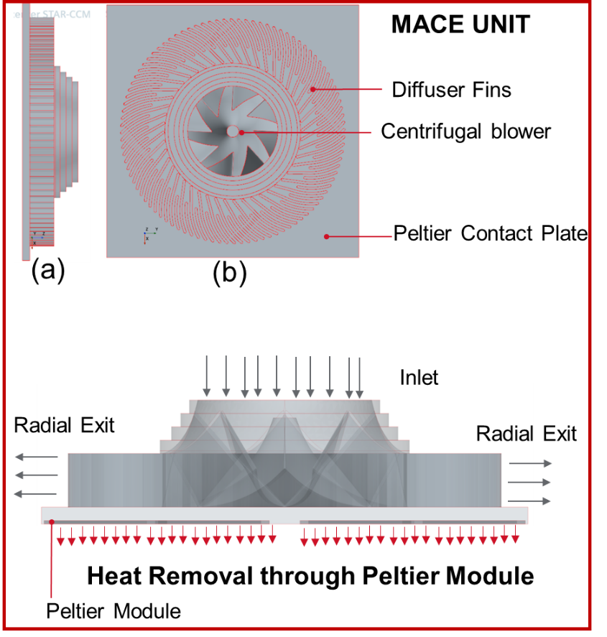

Figure 2 Detailed description of MACE unit

# 1D Simulation Setup using SIMSCAPE

A 1D model was prepared using SIMSCAPE to provide us with an initial value of heat flux of the Peltier plates so as to reduce the time in trial error when the CFD simulation was being performed. It was seen that the value predicted by the SIMSCAPE was about 10% higher than the actual heat flux required by the system in the CFD simulation. The SIMSCAPE model created can be seen in Figure 3

Figure 3 SIMSCAPE Model for the Galley system

# Meshing and Simulation setup

## Mesh Parameters

A structured polyhedral mesh is being generated for the various bodies using ANSYS Fluent and STAR CCM+ meshing. There is special attention given to the various interfaces between the solids and fluid. A clear inflation layer in terms of prism layers is established to capture the thermal gradient that are forming in these interfaces which is observed in the mesh as seen in Figure 4. The mesh around the centrifugal pump is also very fine as it can be seen in Figure 5. Meshing is carried out in two software’s simultaneously as there were issues in the CAD provided to us and the ANSYS Fluent meshing was able to resolve these surface defects on its own, however the STAR CCM+ meshing was not able to resolve it and these surfaces were needed to be repaired manually. Simulations were performed on both STAR CCM+ and ANSYS Fluent to save time as there were limited number of licenses available for both.

Figure 4 Polyhedral structured mesh

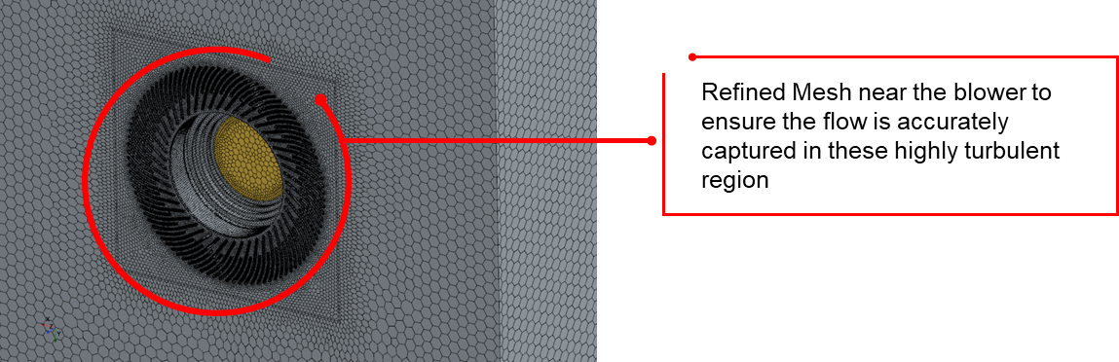

Figure 5 Areas of refinement for the mesh created

## Simulation Setup

The governing equations used in the simulation consists of two-dimensional equations of continuity, momentum, turbulence and energy. These equations are discretized using Finite Volume Method (FVM) by the software tool using the above specified numerical schemes which are subsequently solved in the form of linear simultaneous equations using Matrix solution techniques. The following are the Reynolds Averaged Navier-Stokes (RANS) equation used in the analysis. The RNG K-Epsilon model was used to simulate the model, the standard wall functions were used to model the wall function. The RNG K-Epsilon model was used as it was seen during the initial literature survey that for heat exchangers the turbulence model that gave the closest results to experimental results was the RNG K-Epsilon model [3]. The RNG K-Epsilon model is described below:

Continuity equation:

 (1)

Momentum equation:

 (2)

Energy equation:

 (3)

The RNG *k-ε* turbulence model:

 (4)

 (5)

The eddy viscosity is given by,

 (6)

The following are the constant values used in the above equations,

C1є = 1.42, C2є = 1.68 and Cµ = 0.0845.

Also, $G_{k}=-ρ\overline{u_{i}^{'}u_{j}^{'}}\frac{∂u_{j}}{∂x_{i}}$, $C_{2ϵ}^{*}=C_{2ε}+\frac{C_{μ}η^{3}(1-\frac{η}{η_{o}})}{1+βη^{3}}$

$η={Sk}/ε$, β=0.012, $η_{o}=4.38, C_{2ε}=1.68, C_{1ε}=1.42,$

$C_{μ}=0.0845 and α_{ε}=α_{ε}=1.393$.

# Solution and Results

With the current boundary conditions and the mesh obtained a good convergence is seen in Figure 6.It can be seen that the levels of residuals have dropped to converged levels within the initial 1000 iterations but however our main convergence criterion is the volumetric average of the cart which needs to achieve a steady state. Only after this temperature reaches steady state is the simulation considered to be converged. The steady state of temperature which is achieved can be seen in Figure 7.

Figure 6 Residuals

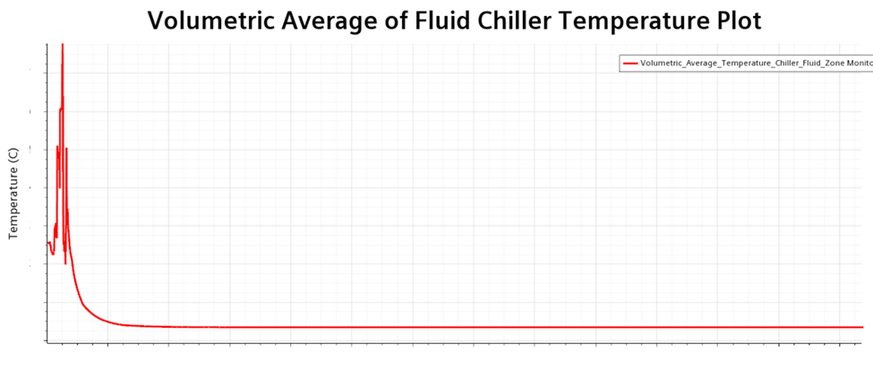

Figure 7 Temperature Monitor Plot

# Design Iterations

A total of 20 manual design iterations were performed where the simulation setup, meshing and all other parameters are the same as described to in the above sections. These 18 designs can be divided into four main categories as listed below.

1. Baseline Designs
2. Duct Designs
3. Additional MACE unit
4. Experimental Designs.

## Baseline Designs

### Initial Simulation with no modifications. (Design A)

An initial simulation was performed by placing the MACE unit at the center to understand the fundamental flow physics occurring. This provided us with various insights as to how the flow effects the temperature distribution across the CART. Through a volume render of temperature in Figure 8 we can visualize the temperature distribution that is formed due to the air flowing through the domain.

Figure 8 Volume Render of temperature

An in-depth analysis is carried out to understand the flow physics and understand the cause of such an uneven temperature distribution which is seen in Figure 8. A section plane is considered as shown in Figure 9 to evaluate the flow characteristics. Through the help of Figure 10 it is seen that there are numerous recirculation zones. The flow passing though both the direction is causing an inflection point at the back which causes an increase in temperature and that increase temperature can be seen in Figure 8. In Figure 11 the variation of temperature towards the back which higher can be clearly seen. This enforces the fact that further design modifications are required.

Figure 9 Plane Section Considered

Figure 10 Velocity Vector Plots in the plane section

Figure 11 Contours of temperature distribution from side view.

### Asymmetrical placement of MACE unit (Design B)

Based on the fact that there was an inflection point that was formed in the center of the back section a design iteration was proposed to place the MACE unit at a particular end which could eliminate the inflection point being formed. However, it can be seen in the volume render of temperature in Figure 12 the inflection point instead of eliminating has just translated to the opposite side.

Figure 12 Volumetric Render of temperature

## Duct Designs

### Baseline Duct Design (Design C)

The designs above have shown that there needs to be a defined path for the air to pass through so that it eliminates the inflection point that is caused at the back. Thus, a duct system was introduced so as to streamline the flow direction and make sure there is a better distribution of temperature. There are two ducts that are introduced which can be seen in Figure 13, one to guide the hot air through the inlet of the centrifugal blower and the outlet section to guide the cold air out. The objective of this duct design was to enable to flow to complete one complete revolution as seen in Figure 14.

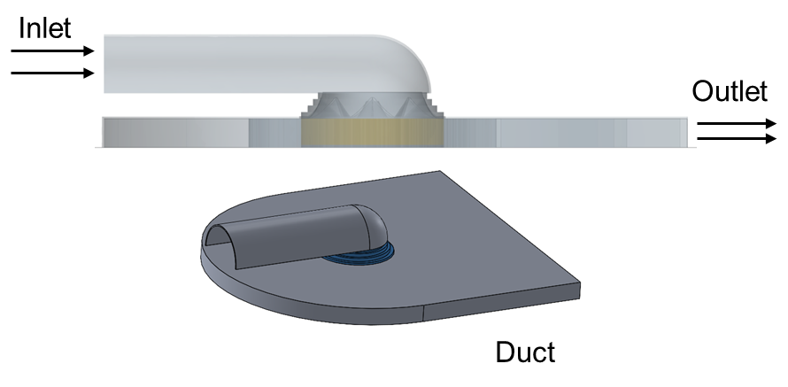

Figure 13 Design of duct

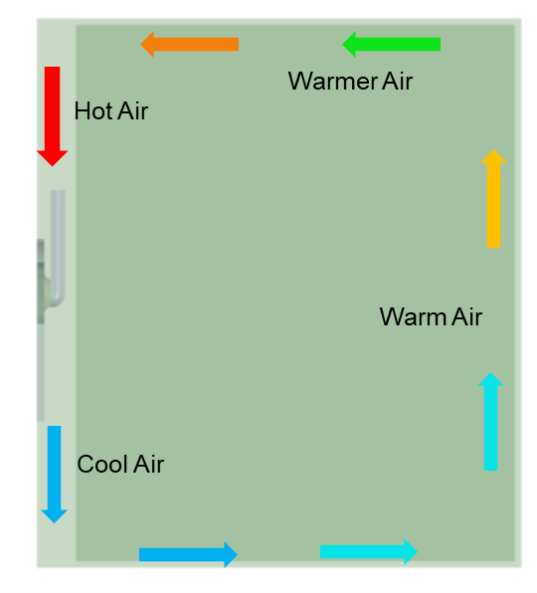

Figure 14 Visualized Circulation of air.

In the baseline duct design the inlet flow and the outlet flow are parallel to each other as seen in Figure 15. It is seen that there is significant improvement in the temperature distribution of the cart which can be observed in the volume render in Figure 16. It is seen that the visualized idea of air flow in Figure 14 is being achieved as seen in Figure 16. However, near the top there are regions of higher temperature which has reduced the uniformity of temperature.

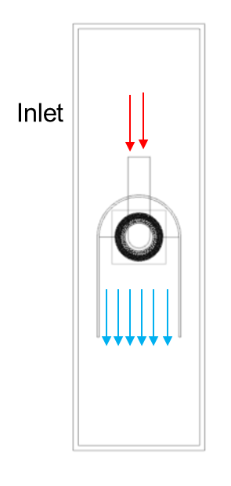

Figure 15 Duct configuration of baseline duct design.

Figure 16 Volume Render of temperature for baseline duct design

### Duct Baseline Design 2 (Design D)

Due to the higher temperature on the top section of the cart as seen in Figure 16 it was proposed that the direction of the duct be rotated by 90deg so as to enable the flow of cold air to the larger area which was visualized to reduce the temperature on the top section. The proposed design can be seen in Figure 17. This was not achieved as the design caused the formation of temperature hotspots on both the top and bottom surfaces as seen in Figure 18. This caused the uniformity of the temperature to degrade even more when compared to the previous case.

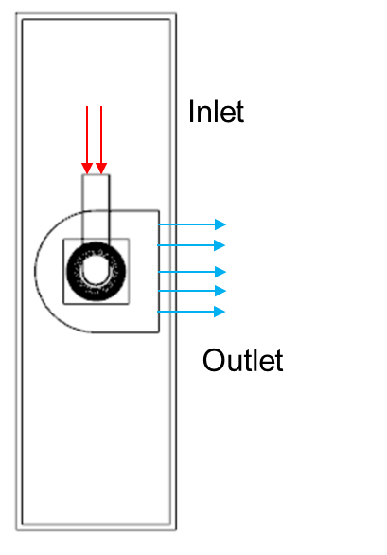

Figure 17 Schematic for Baseline duct design 2

Figure 18 Temperature volume render for Design D

## Additional MACE Unit

To counter the problems which arose in the previous designs a call was taken to introduce and additional mace unit which would help in cooling the relatively large area. Clearly one MACE unit was underpowered to be able to sufficiently cool the whole cart. It was also decided that the duct design for both the MACE units was the way ahead as it provided us with major advantages in terms of controlling the flow cold air and to be able to direct it in a way of our requirements.

### Orthogonal arrangement of MACE units- 1 (Design E)

When the two MACE units were introduced, it was decided to combine the two best designs we had so far which was designs C& D. This combination resulted in an orthogonal configuration which is seen in Figure 19. This design iteration did not yield in the results that were expected due to the fact that the two MACE units were operating under two different temperature ranges as seen in Figure 20. The difference in the temperature near the MACE units was caused due to cold air from the MACE unit at the bottom being directly fed into inlet of the MACE unit on the top. This caused the MACE unit at the top to cool air which was already cool which seriously, hindered the efficiency of the pump. Even without the help on velocity vector plots it can be clearly seen that the cold air is moving towards the inlet of the top MACE unit in Figure 20.

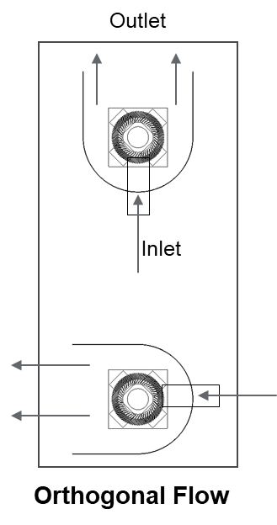

Figure 19 Design schematic for orthogonal configuration

Figure 20 Temperature distribution render for Design E

### Orthogonal arrangement of MACE units- 2 (Design F)

It was learnt that since there are two MACE units introduced the power consumed was also doubled, however this couldn’t be achieved in real life, hence a simulation was performed by divided the power between the two MACE units equally. A temperature distribution which is similar in distribution can be seen from Figure 21.

Figure 21 Temperature distribution render for Design F

### Orthogonal arrangement of MACE units- With Modified Inlet (Design G)

As seen in Figure 20 and Figure 21 due to the inlet shape and position the cold air was being drawn into the MACE unit on the top. A design change in the shape of the inlet duct was proposed which is seen in Figure 22. The purpose of this modified inlet was to help draw in more hot air so that the temperature in the lower MACE unit also reduces to some extent and its efficiency in terms of cooling air also increases. However, the perceived flow was not possible and the temperature render in Figure 23 reinforces the same. There is no difference in the temperature distribution from the previous cases hence it was decided to revert to the old inlet design.

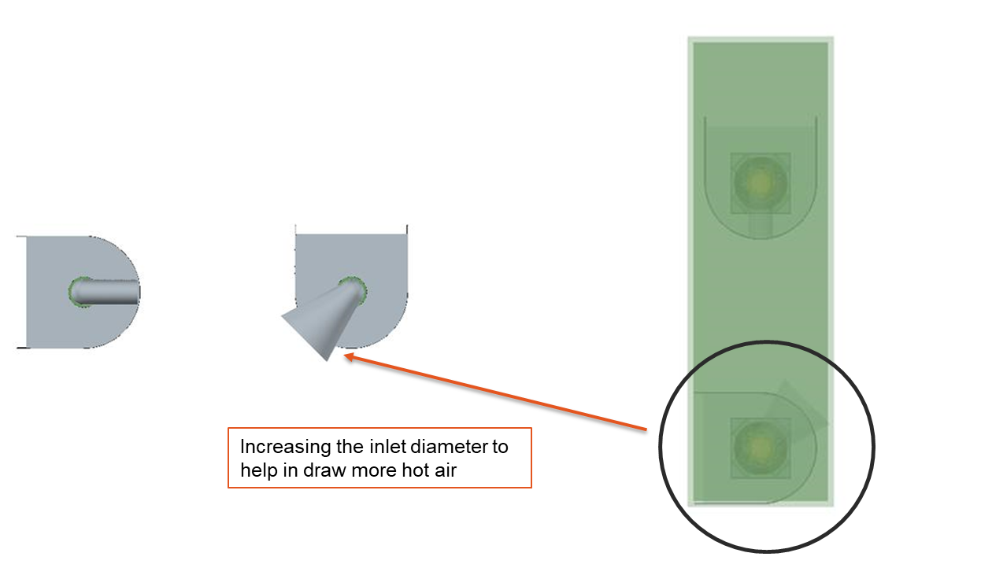

Figure 22 Design of Modified inlet

Figure 23 Temperature distribution render for Design G

### Unidirectional arrangement of MACE units (Design H)

Since the orthogonal placement was not able to achieve the requires results it was suggested that both the MACE units be place in the same direction, i.e. the outlets of both MACE units be placed in the same direction, this design can be seen in Figure 24. This design was perceived to eliminate the flow of cold air from MACE unit towards the other causing the problems which we saw in the above designs. In Figure 25 it can be seen that the flow of hot air from the MACE unit at the bottom to the MACE unit has reduced but has not been completely eliminated, There still exists a colder region at the top of cart which is causing non-uniform distribution of temperature.

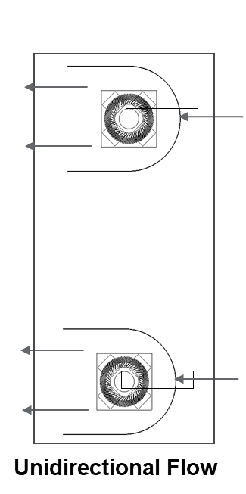

Figure 24 Design Schematic for unidirectional arrangement

Figure 25 Temperature distribution render for Design H

### Unidirectional arrangement of MACE units with Reduced Volume (Design I)

A major design modification was made to reduce the volume of air present near the MACE units, this can be seen in Figure 26. This was done to reduce the amount of recirculation of cold air towards the inlet of the MACE units. Through Figure 27 it can be seen that there is an increase in the uniformity of temperature which shows that steps are being taken in the right direction, however the uniformity obtained was not sufficient, as there were still major recirculation zones and the unwanted mixing of flows.

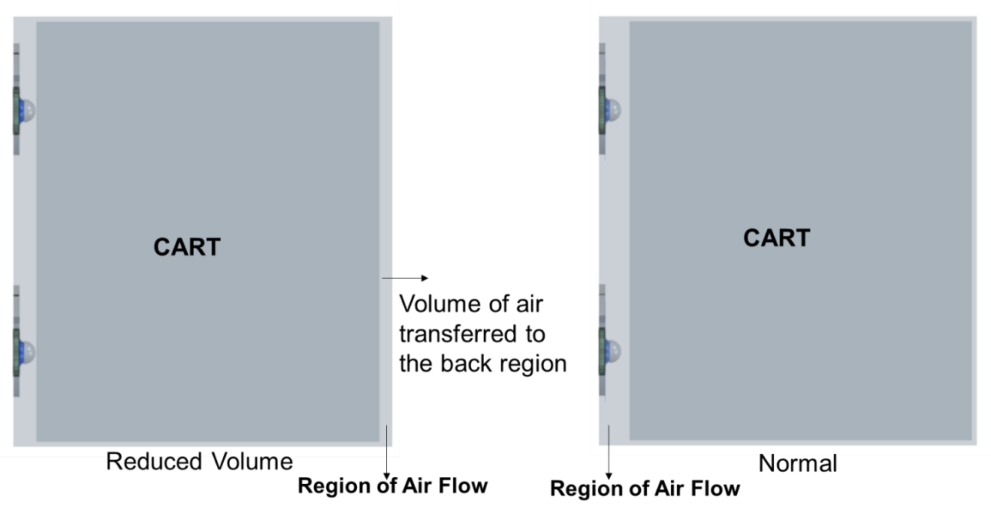

Figure 26 Reduced Volume Design Modification

Figure 27 Temperature distribution render for Design I

### Unidirectional arrangement of MACE units with Reduced Volume with guide vanes (Design -J)

Due to the mixing of flow between the two MACE units guide vanes were added at the outlet of each of the MACE units. The mixing of the flows can be visualized through the help of Figure 28 which is the velocity vector plots of the previous design. The dead zones and the momentum loss which was seen are highlighted in Figure 28. Thus, the guide vanes are suggested which can be seen in Figure 29.

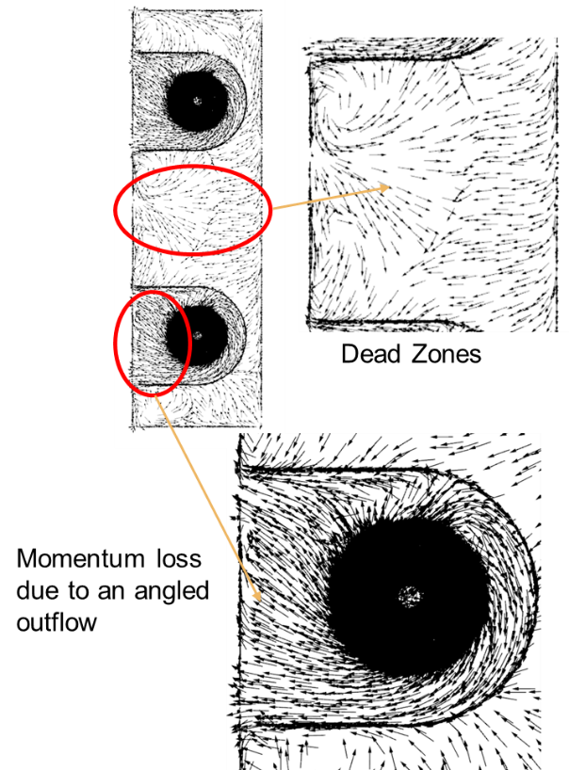

Figure 28 Velocity vector plots of Design I

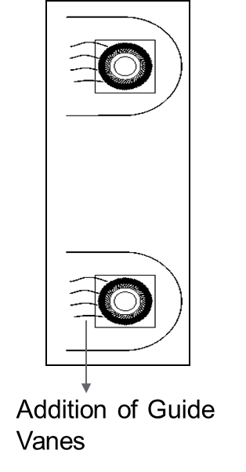

Figure 29 Schematic of Guide Vanes added

The results when the guide vanes are added are very promising as seen in the temperature distribution in Figure 30. There is reduced recirculation due to the guide vanes that were introduced this can be seen in Figure 31. In this case there are formation of recirculation zones right inside the duct which is highlighted in Figure 31. It can also be observed that the temperature distribution between the MACE units has reduced when compared to previous cases. However, there is still room for improvement.

Figure 30 Temperature distribution render for Design J

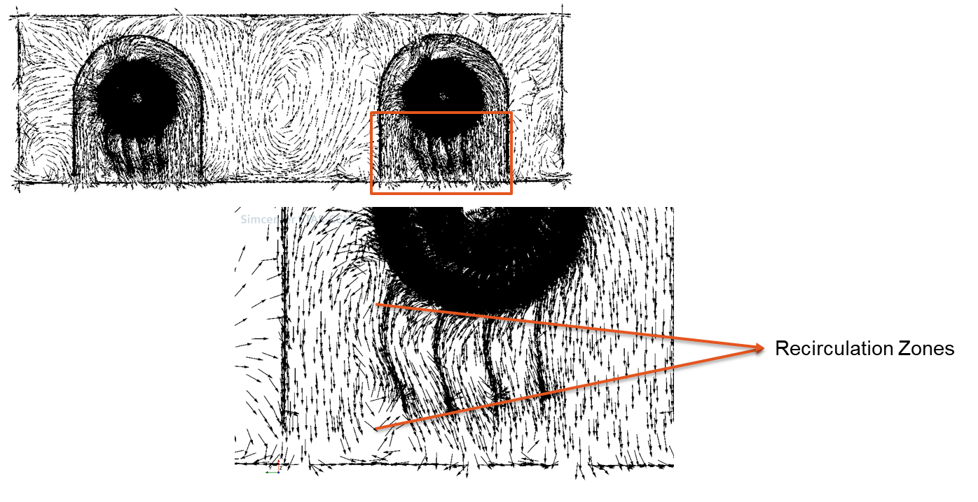

Figure 31 Velocity Vectors of the MACE units with Guide Vanes

### Bidirectional MACE units with split (Design K)

It was decided to isolate both the MACE units from the effects of each other by using a split plate as seen in Figure 32. This will ensure that there is no interaction at all between the two MACE units which will result in both the MACE units working at the same temperature ranges. The orientation of one of the MACE units was rotated by 1800, This was done to ensure that the hot air doesn’t get accumulated on one side of Galley system. All the design enhancements that were done till now i.e., reduced volume, guide vanes were incorporated in this design with the hopes of getting a better result.

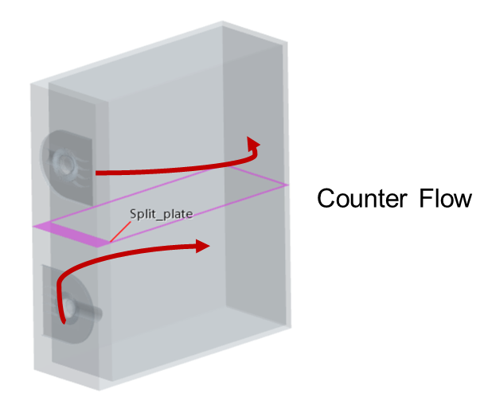

Figure 32 Design Specifications for bidirectional split configuration

The resulting temperature distribution obtained is the best one obtained till now and can be seen in Figure 33. Both the MACE units are working in the same temperature ranges, and there are no adverse temperature gradients observed on the cart. From the two views seen in Figure 33 it can be clearly seen that the temperature distribution is perfectly symmetric. However, in the highlighted region of Figure 33 it can be seen that there is high temperature zone which is similar to an inflection point seen in Figure 11. Apart from this the distribution of temperature is uniform and desirable.

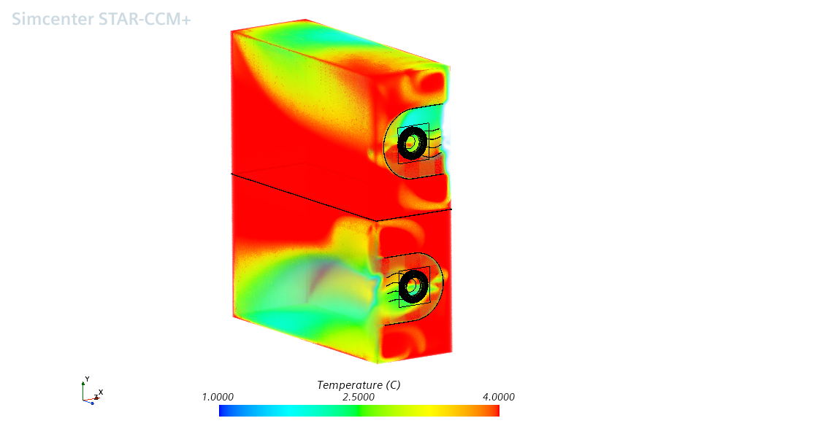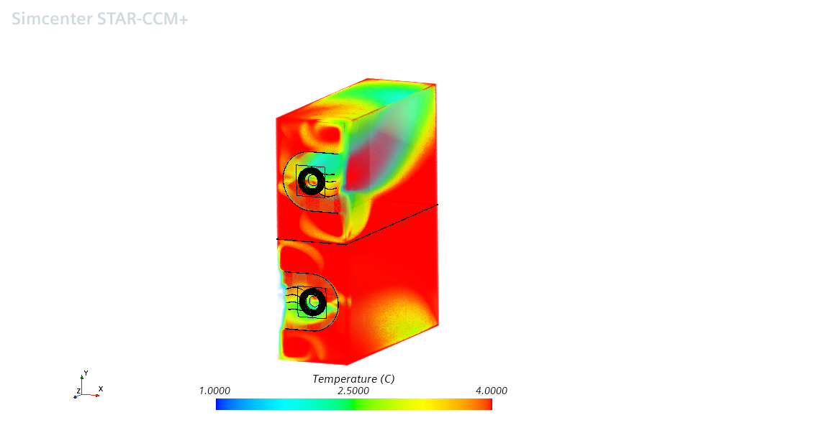

Figure 33 Temperature distribution render for Design K

### Bidirectional MACE units with quarter split (Design L)

Since a good temperature distribution is obtained in Design K, further modifications were made to it to eliminate the high temperature zones at the end of the cart. A split plate concept was retained but however it was used partially, in the sense the end of the split plate was cut of to enable the mixing of flow at the end to enhance the temperature distribution. This concept can be visualized through Figure 34.

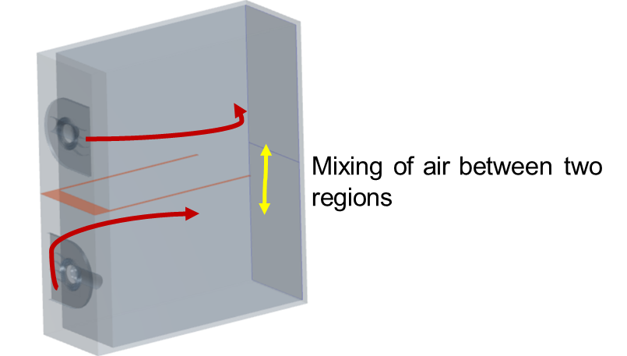

Figure 34 Schematic for quarter split concept

When the temperature renders (Figure 35) for this design are observed it is seen that there Is sufficient mixing between the flows from the MACE units to eliminate the temperature hotspot at the end and this can be seen in the temperature plots overlayed with the velocity vector plots in Figure 36. This design has achieved the best uniformity and met the goals set. Further investigations are carried out to check if there is any room to further improve the uniformity.

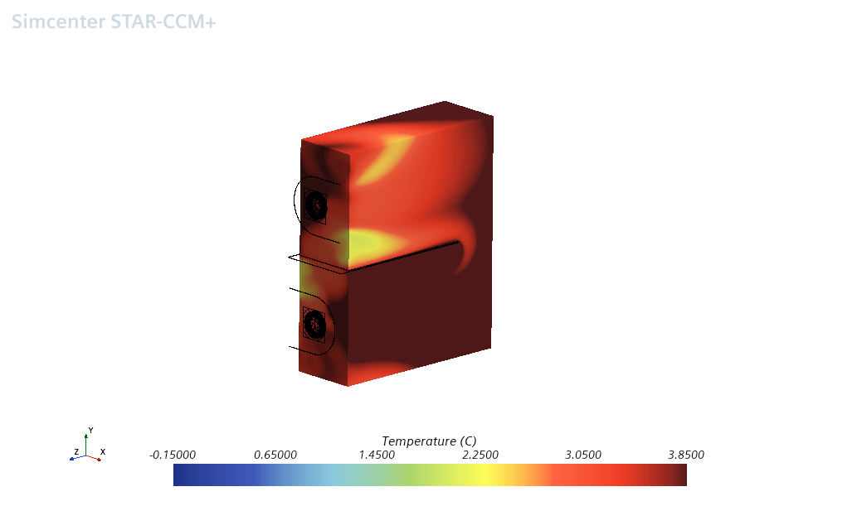

Figure 35 Temperature distribution render for Design L

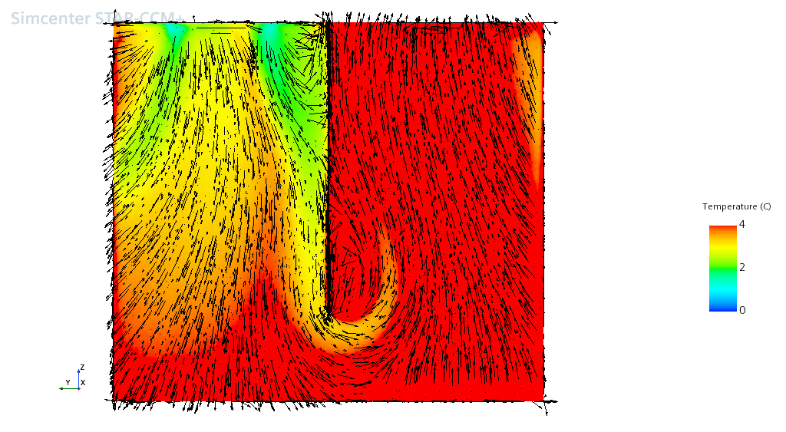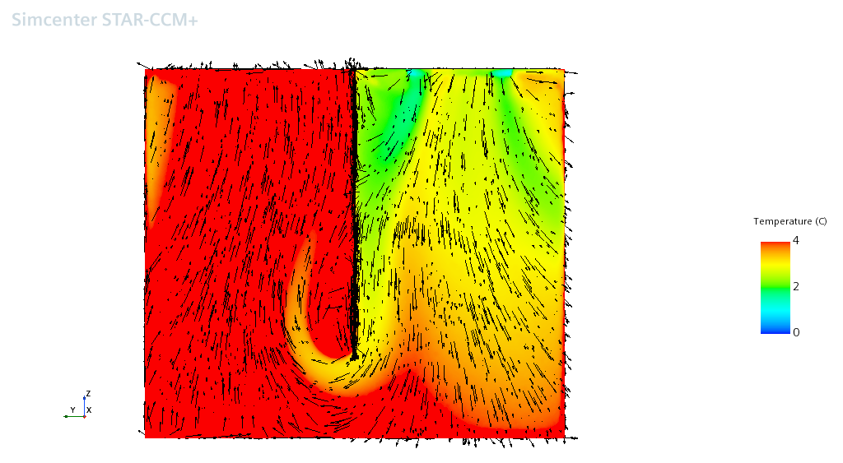

Figure 36 Temperature contours overlay with velocity vectors for Design L

### Bidirectional MACE units with quarter split and taper (Design M)

With design L meeting the uniformity criteria it was decided to introduce a taper in the duct guiding the cold air from the outlet of the blower. This taper can be visualized in Figure 37. This taper was introduced to reduce the recirculation of the flow coming out of the corner of the duct. However, the desired result was not achieved as the taper caused a massive loss in momentum which reduced the temperature uniformity of the cart that is seen in Figure 38.

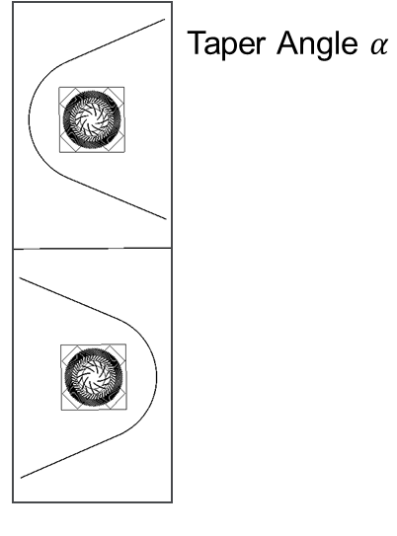

Figure 37 Schematic for tapered outlet duct

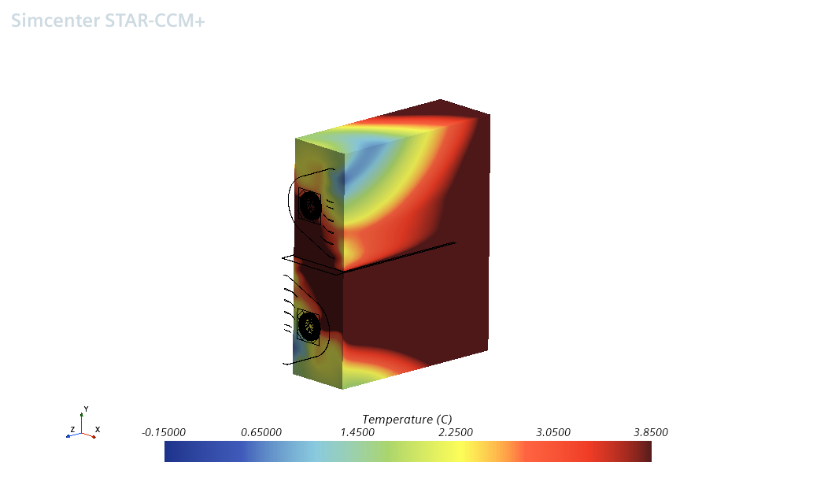

Figure 38 Temperature distribution render for Design M

## Experimental Designs.

A few designs were experimented at the end to explore a few more avenues to check if there is any way to achieve a better uniformity, there are two designs that are explored which are elaborated below.

### Volute Design (Design N)

A volute is used to replace the outlet duct. This volute and the equation used to construct this volute can be seen in Figure 39. However, the temperature distribution not optimal as seen in thus this design was discarded.

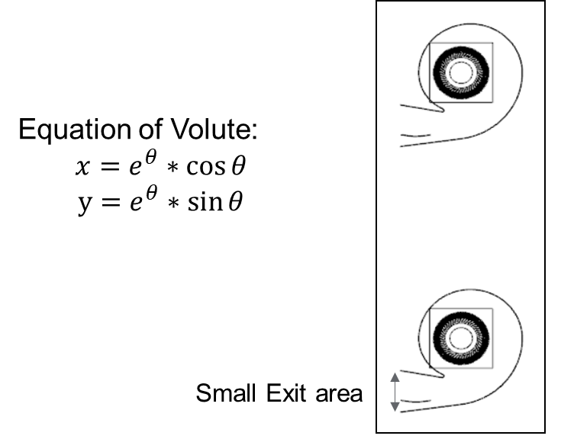

Figure 39 Schematic of Volute Design

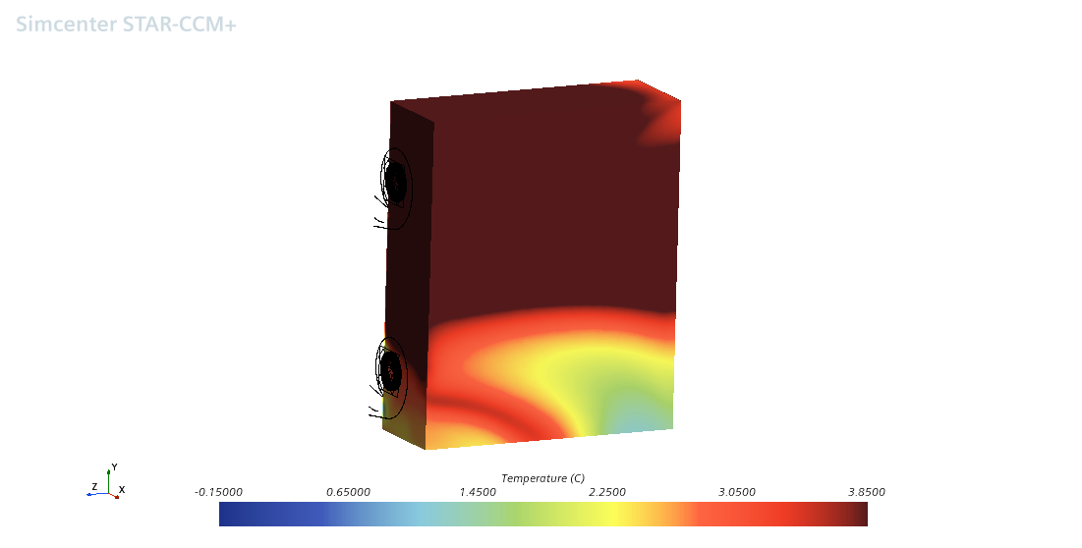

Figure 40 Temperature distribution render for Design N

### Three Mace units with quarter splits. (Design O)

An additional MACE unit was introduced with quarter splits in between. The total power consumed by the system does not change hence each MACE unit consumed one-third of the power. This design can be visualized from Figure 41. However, from the temperature render in Figure 42 it was clearly seen that there were massive recirculation zones and there was not sufficient uniformity obtained, hence there was no effort made to improve this design.

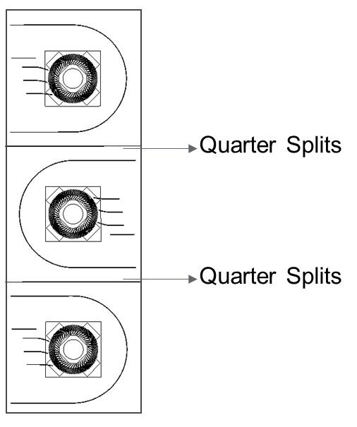

Figure 41 Design Schematic for 3 MACE units

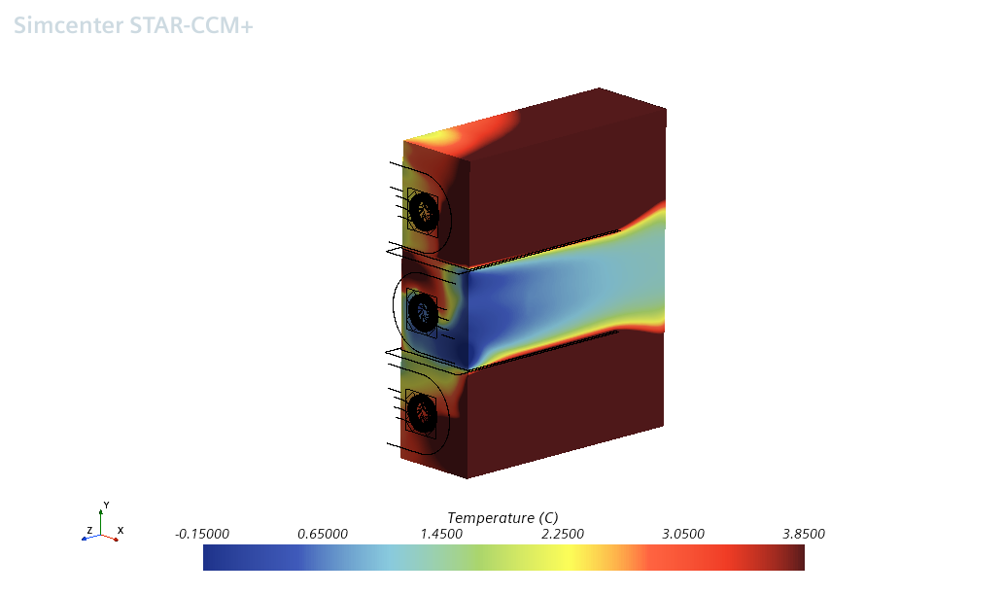

Figure 42 Temperature distribution render for Design O

## Summary of all the design iterations

In Figure 43, the blue line represents the volumetric average temperature in each case, which is same across all the cases. The orange line depicts the standard deviation of temperature in the cart. This variation can be seen for all the design and the lowest standard deviation is obtained in the case of **DESIGN L.**

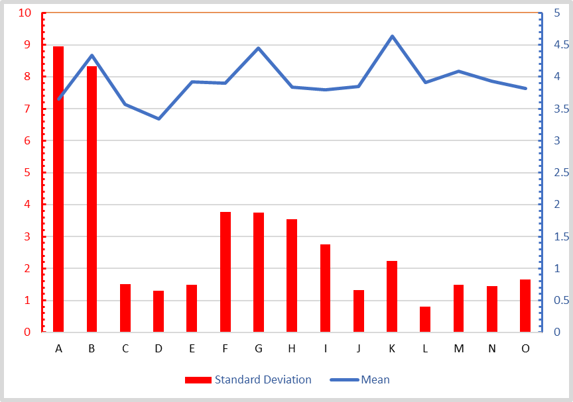

Target Standard deviation

Lowest Standard deviation

Figure 43 Variation of Mean and Standard Deviation across designs

# Design Exploration using HEEDS

## HEEDS

HEEDS (Hierarchical Evolutionary Engineering Design System) is a robust design exploration and optimization software package that automates the search for better and more robust solutions within a given design space and dramatically reduces design time. Parameter optimization, DOE, Robustness and Design Evaluation are some of the capabilities of the solver. Capable of linking various software’s. can be seen in Figure 44. Using SHERPA algorithm with equal weighted objectives the simulation is being run. SHERPA - A direct optimization algorithm in which all function evaluations are performed using the actual model as opposed to an approximate response surface model. A Pareto setup is not used as we are not trying to solve conflicting objectives.

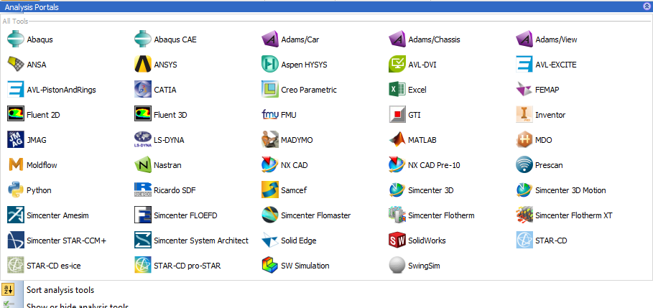

Figure 44 Various software’s capable of coupling with HEEDS

## HEEDS optimization setup.

The best design i.e., Design L is further optimized with the help of HEEDS. There are various geometric variables that are set and given appropriate limits so that HEEDS can successfully optimize the best design L we have till now. The four major variables are Radius of the Duct, Taper Angle of the Outlet Duct, Length of the Primary Duct, and Length of the Split Plate this can be seen in Figure 45. There are further 20 variables that define the shape of guide vanes accordingly. The variables that are defined can be seen in Figure 46. Six objectives were set to optimize the temperature and the pressure as seen in **. There was a total of 50 design iterations performed by HEEDS to optimize the model.

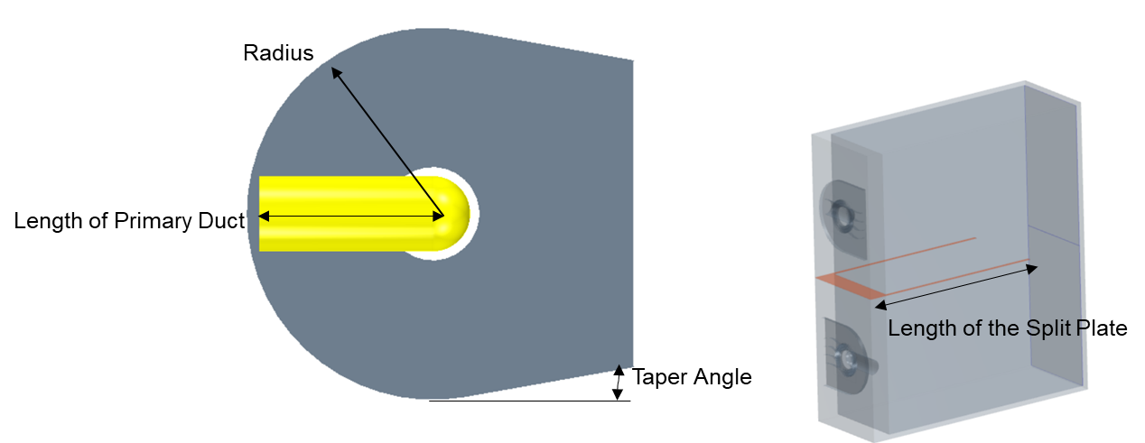

Figure 45 Major Variables defined in HEEDS

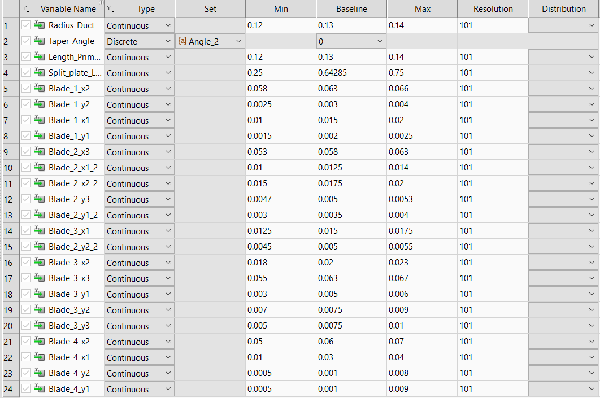

Major Input Parameters

Guide Vanes geometry configurations

Figure 46 Variables defined in HEEDS

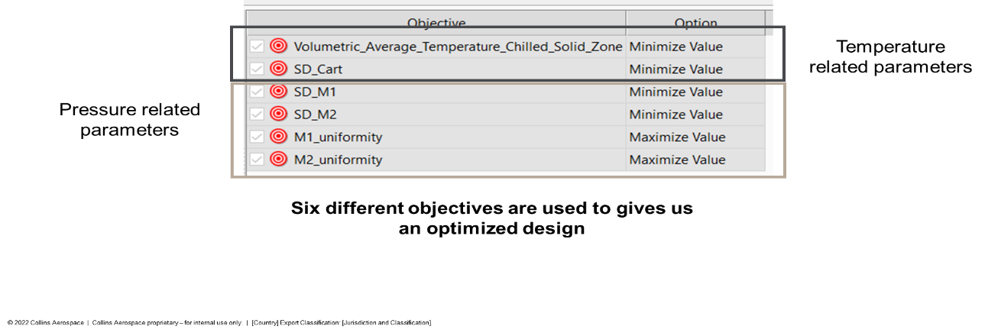

Figure 47 Variables used for optimization

## Optimization Results

HEEDS ran 50 designs, out which 4 failed due to hardware issues as seen in Figure 48 however in the 46 designs that were completed it was seen that there is **50% improvement** in the standard deviation of the CART which is well below the target set. The simulation files were made available by HEEDS and further analysis of this design shows significant change in the design of the ducts and guide vanes as seen in Figure 49.

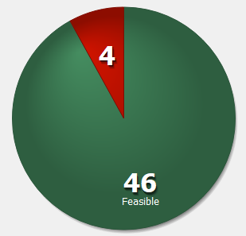

Figure 48 Simulations run by HEEDS

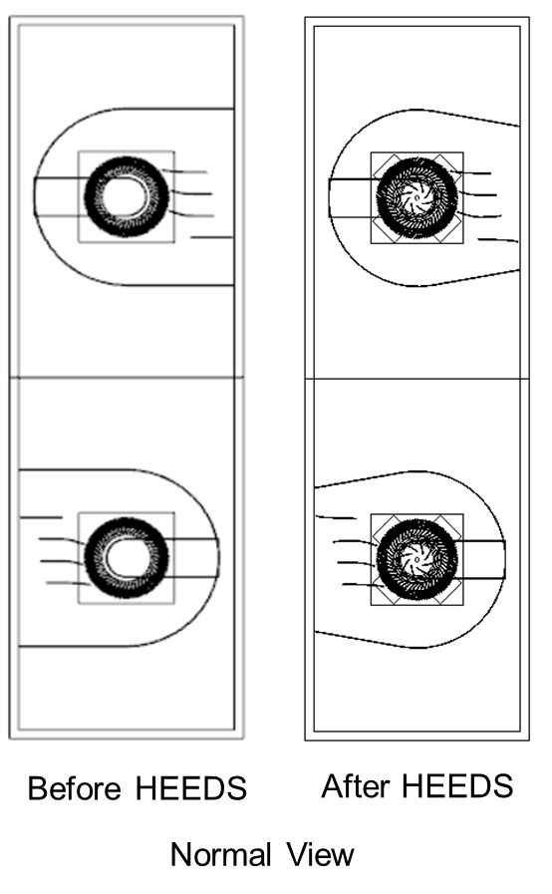

Figure 49 Comparison of designs, before and after optimization

# Co-simulation using MATLAB

The thermoelectric plate/ Peltier plates that are modeled in CFD have a constants heat source. However, this is not the case in real life, we need to be able to capture the current that is consumed by the Peltier plates to be able to predict the power requirements of the MACE unit. Thus, a thermoelectric plate model was created in SIMULINK as seen in Figure 50.

Figure 50 Simulink model for thermoelectric plates.

Once the thermoelectric plate model was created in Simulink it needed to be coupled with STAR CCM+, a transient CFD simulation is performed where there is transfer of data between MATLAB and STAR CCM+ at each time step. As seen in Figure 51 at each time step the CFD solver send the volumetric average temperature of the CART to MATLAB and the controller in the Simulink model predicts the amount of current which is required to be supplied to the Peltier Plates and the corresponding heat flux value is obtained which is sent back to STAR CCM+ where it performs one more time step. This process can be clearly understood through the help of the flowchart in Figure 52. There are two methods that are identified which can be used to couple these two software.

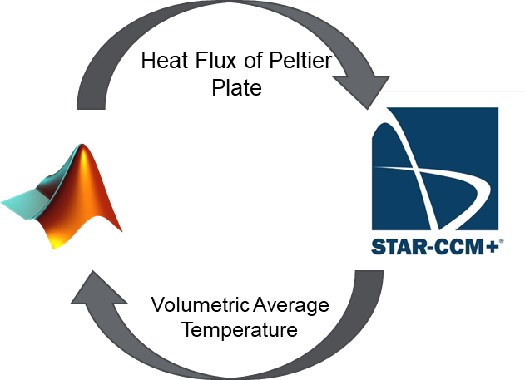

Figure 51 Transfer of data between MATLAB and STAR CCM+

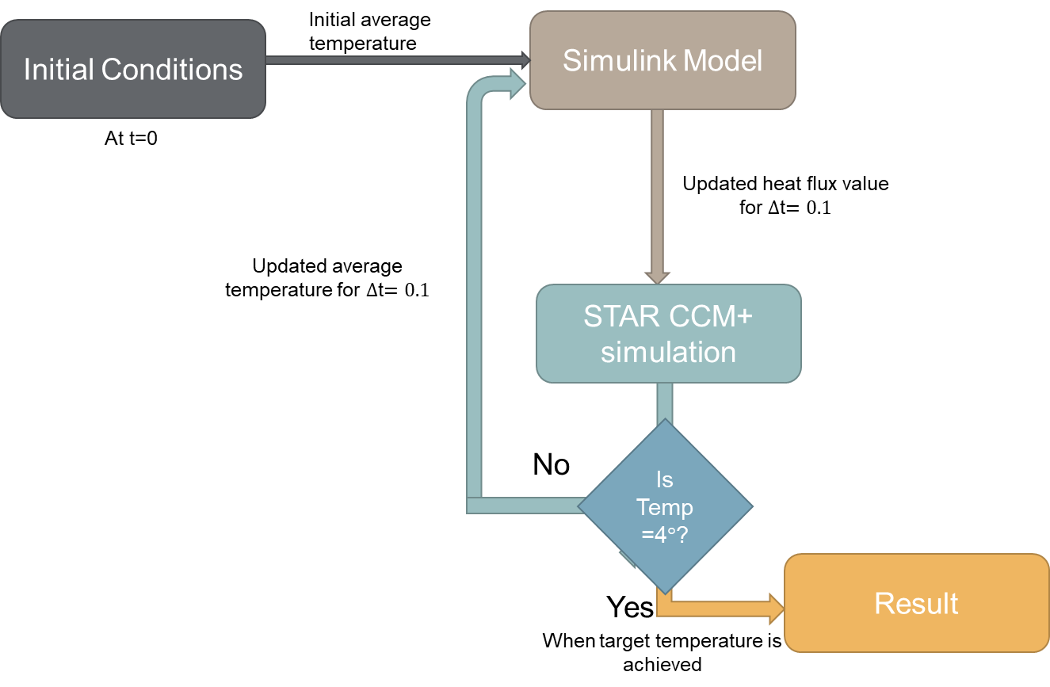

Figure 52 Flowchart depicting the data transfer between the two software

## Method 1: Calling STAR CCM+ from within MATLAB

In this method MATLAB is the lead software where we initialize the values to the atmospheric conditions. Then there is FOR loop configured that has the total time and the time steps. In the FOR loop the initial values of temperature is sent to Simulink which gives out the heat flux, this heat flux is passed onto STAR CCM+ and the simulation is run till that timestep converges. Then the updated value of temperature is sent back to Simulink and this process continues as seen in Figure 52.

## Method 2: Functional Mockup Unit Integration with STAR CCM+

The Simulink model shown in Figure 50 is connected to inports and outports and the whole model is exported to a function mockup unit. This functional mockup unit is imported directly into STAR CCM as seen in Figure 53where the imported values and exported values are clearly indicated. This will make sure that the Simulink model which is converted to a C Code through FMU runs in the background after each time step. This method eliminates the requirement of both the softwares to run at the same time. And also reduces the time required to complete the whole process.

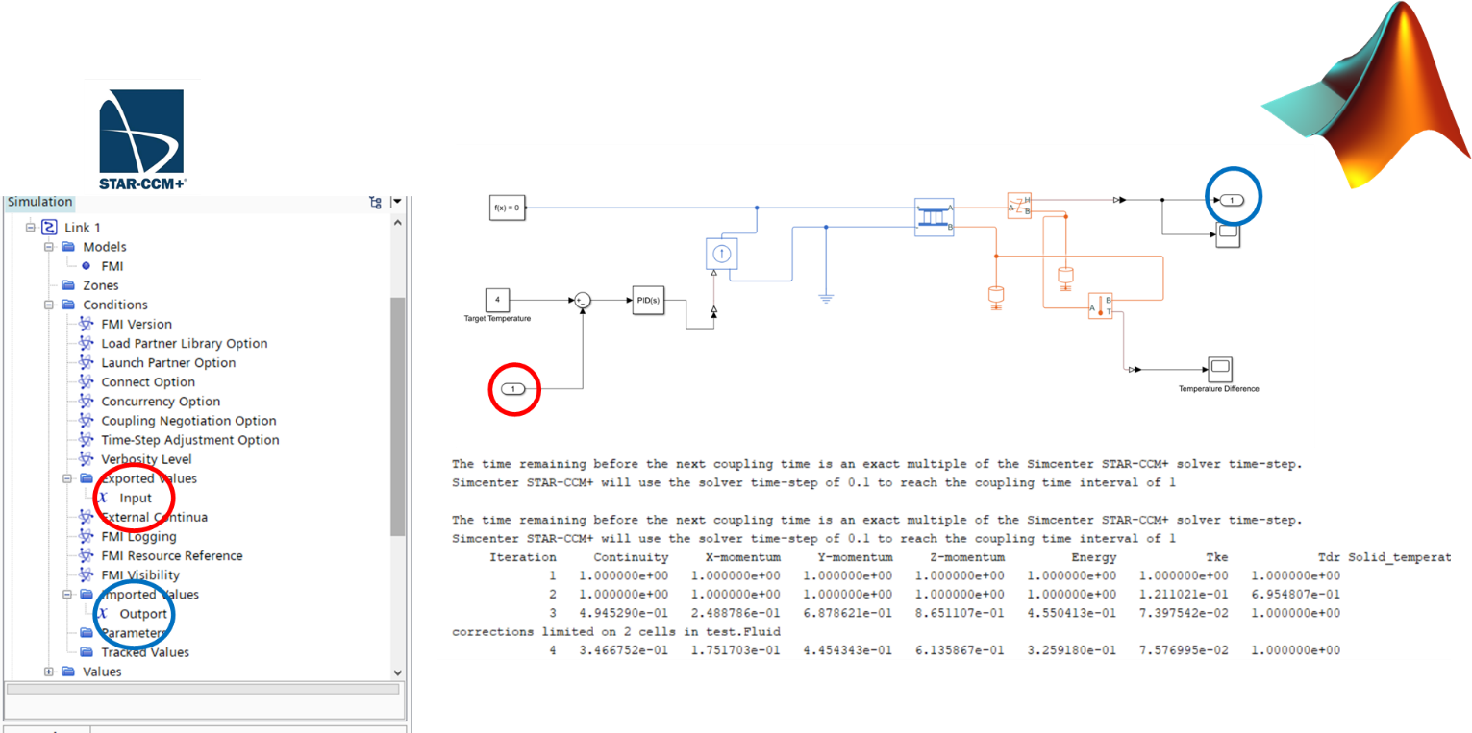

Figure 53 FMU integration in STAR CCM+

# Conclusion

Through the various design iterations, it was found that the Design L was the best and that further optimization using HEEDS software led to an improvement of 50%. To accurately describe the real-life conditions co-simulations were performed where the thermoelectric plates were modeled in Simulink and imported into STAR CCM+.

# References

[1] J. C. Jo, Y. H. Choi, and S. K. Choi, “Numerical Analysis of Unsteady Conjugate Heat Transfer and Thermal Stress for a Curved Piping System Subjected to Thermal Stratification,” Journal of Pressure Vessel Technology, vol. 125, no. 4, pp. 467–474, Nov. 2003, doi: 10.1115/1.1613947.

[2] D. Born, P. Stein, G. Marinescu, S. Koch, and D. Schumacher, “Thermal Modelling of an Intermediate Pressure Steam Turbine by Means of Conjugate Heat Transfer: Simulation and Validation,” Jun. 2016. doi: 10.1115/GT2016-57247.

[3] M. Silieti, A. J. Kassab, and E. Divo, “Film cooling effectiveness: Comparison of adiabatic and conjugate heat transfer CFD models,” International Journal of Thermal Sciences, vol. 48, no. 12, pp. 2237–2248, Dec. 2009, doi: 10.1016/j.ijthermalsci.2009.04.007.

[4] A. Zebib and Y. K. Wo, “A Two-Dimensional Conjugate Heat Transfer Model for Forced Air Cooling of an Electronic Device,” Journal of Electronic Packaging, vol. 111, no. 1, pp. 41–45, Mar. 1989, doi: 10.1115/1.3226507.

[5] A. Koca, “Numerical analysis of conjugate heat transfer in a partially open square cavity with a vertical heat source,” International Communications in Heat and Mass Transfer, vol. 35, no. 10, pp. 1385–1395, Dec. 2008, doi: 10.1016/j.icheatmasstransfer.2008.07.018.